APLIKASI SIM RS BERBASIS WEB  
____________________________________________________________________________________

1. Halaman Login

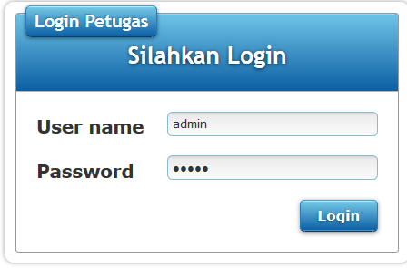

2. Halaman Utama  
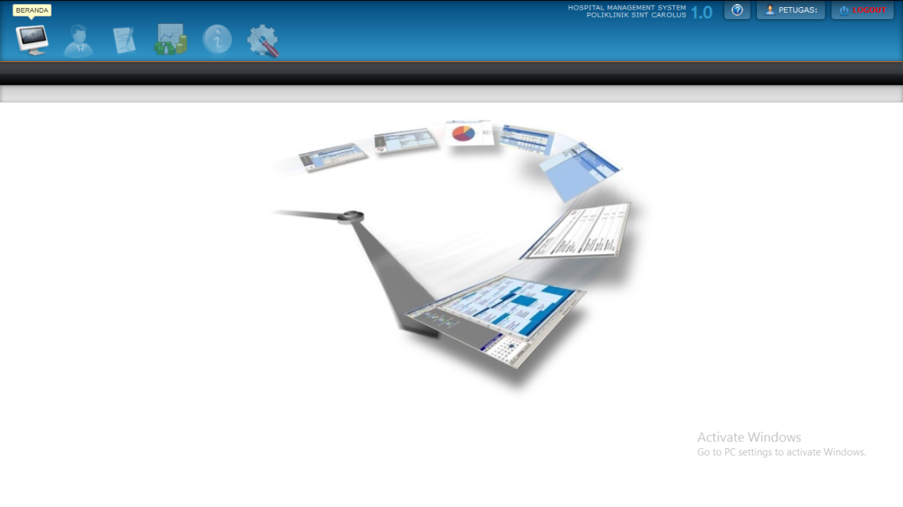

1. Halaman Pasien

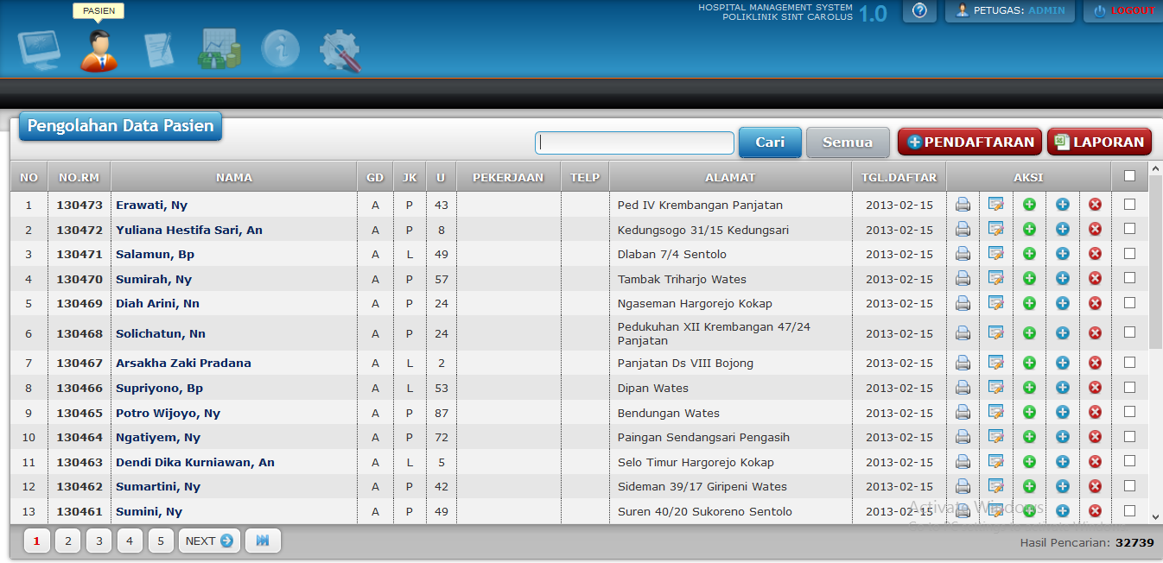

* Pendaftaran Pasien

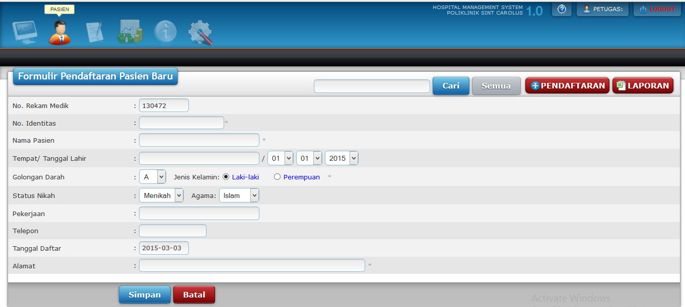

* Cetak Kartu Pasien

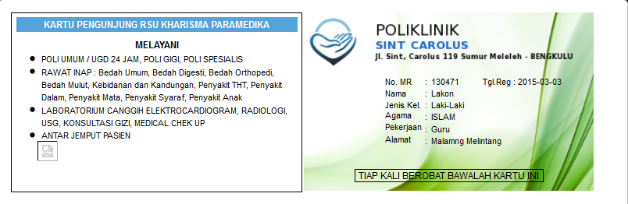

* Edit Data Pasien

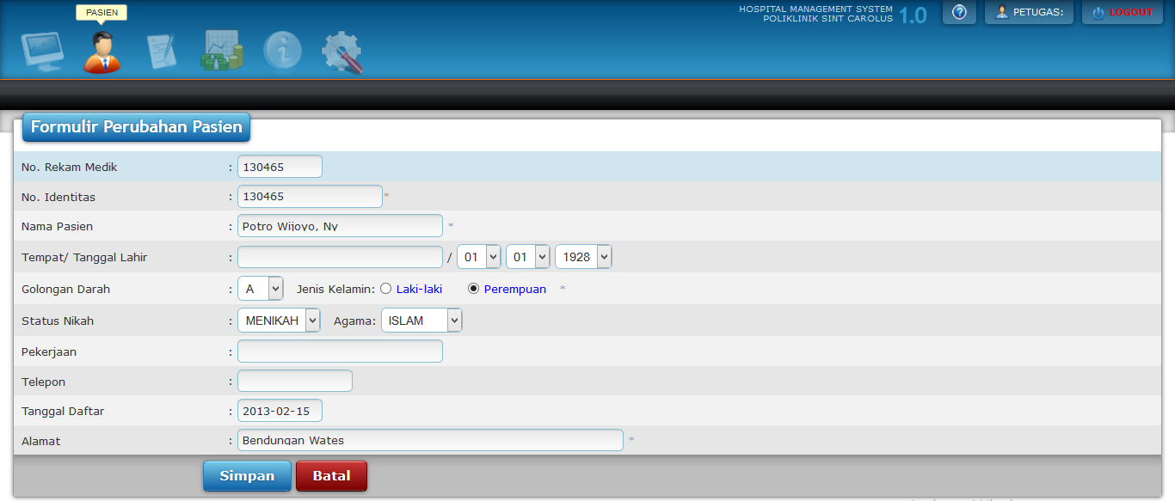

* Laporan data pasien

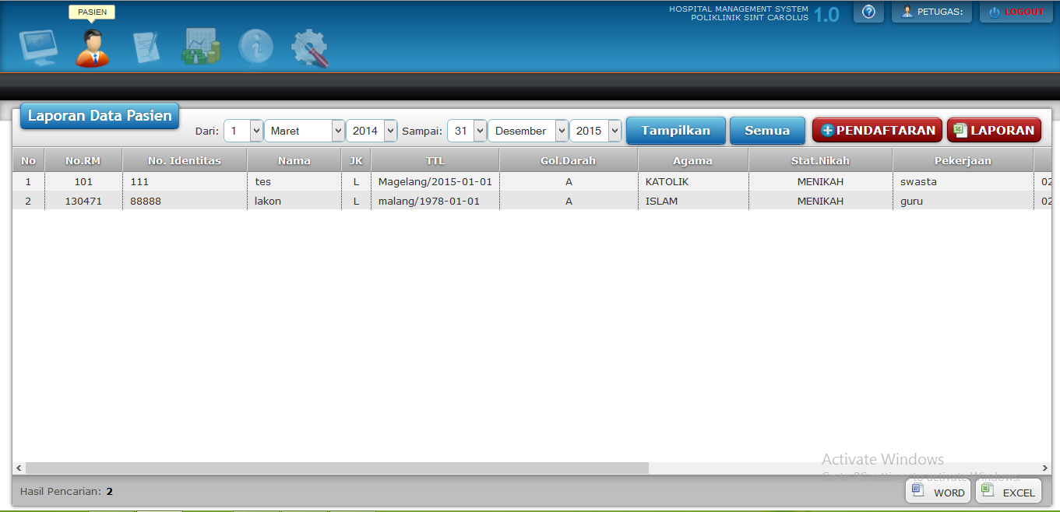

* Registrasi Rawat Jalan

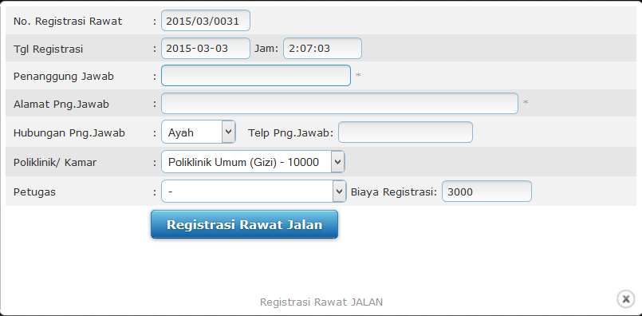

* Registrasi Rawat Inap

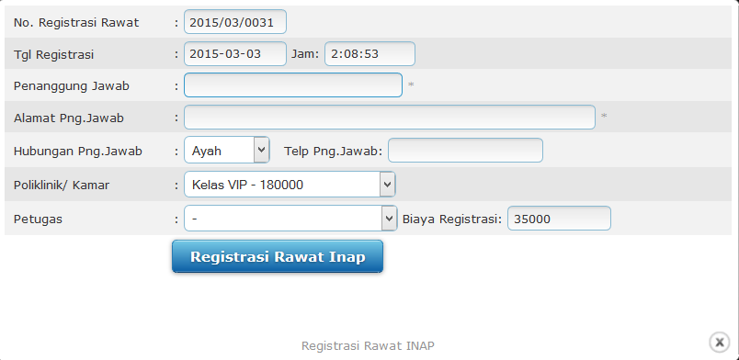

1. Tindakan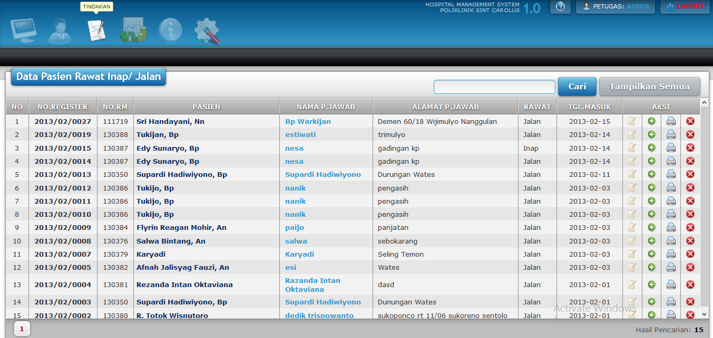

* Tindakan Pasien

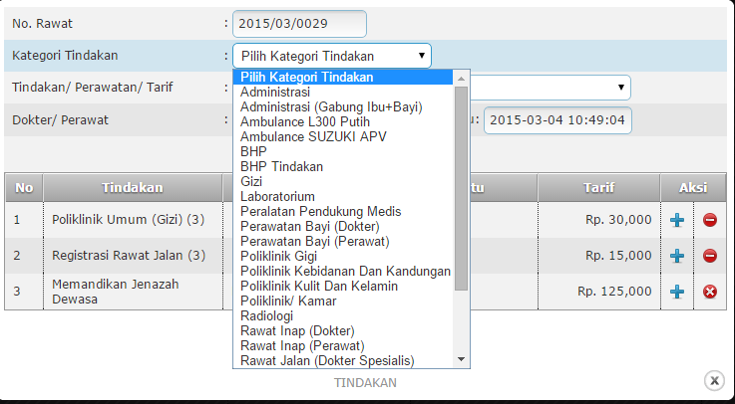

* Obat

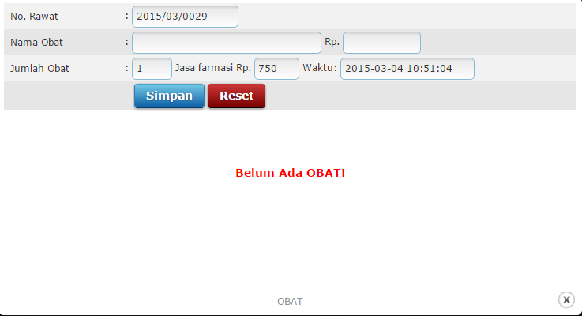

* Cetak kartu rawat

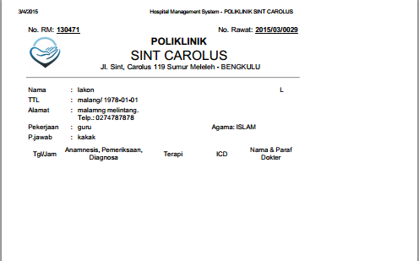

1. Billing

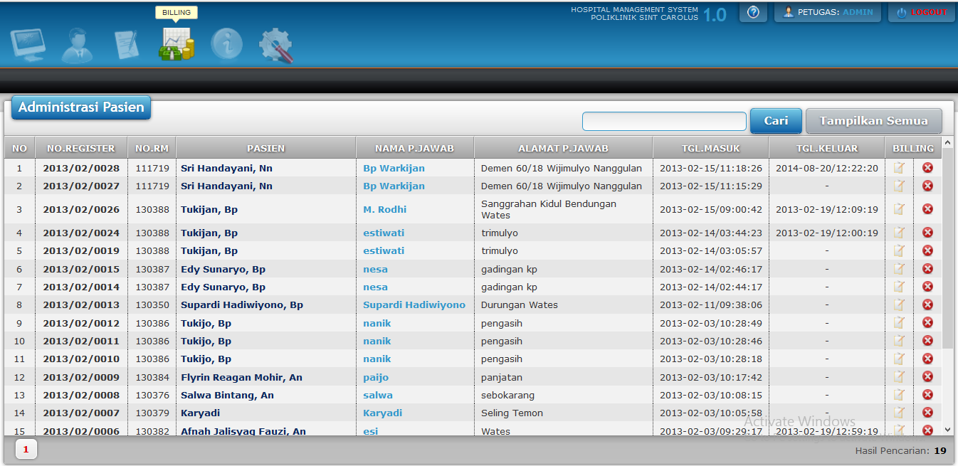

* Tarif Pasien

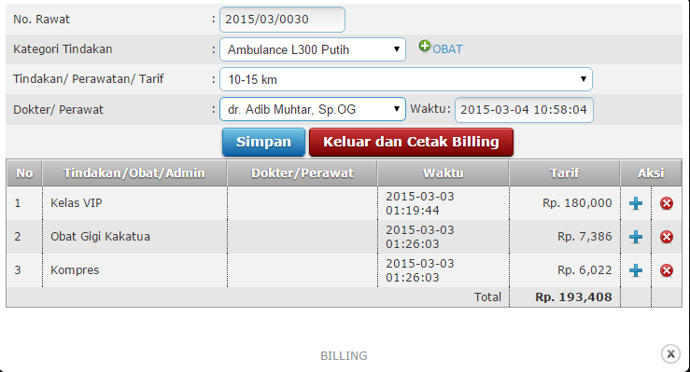

1. Apotik

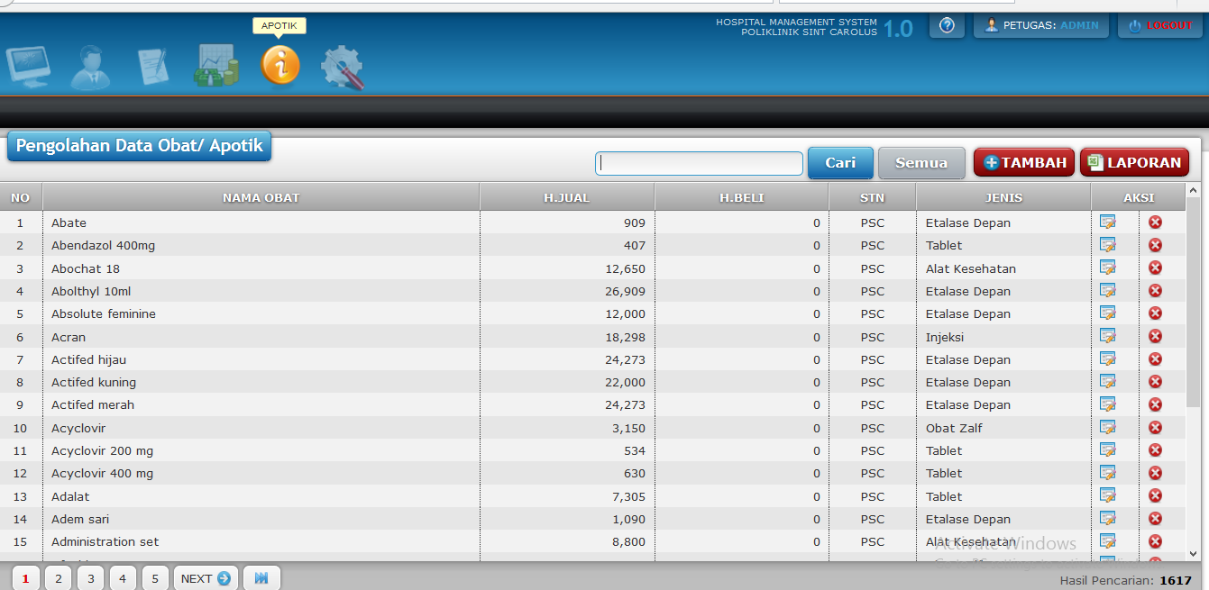

* Penanggung Jawab

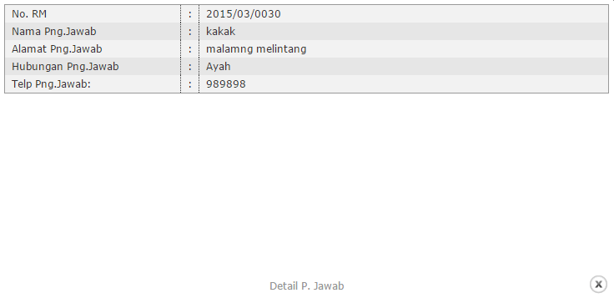

1. Setting

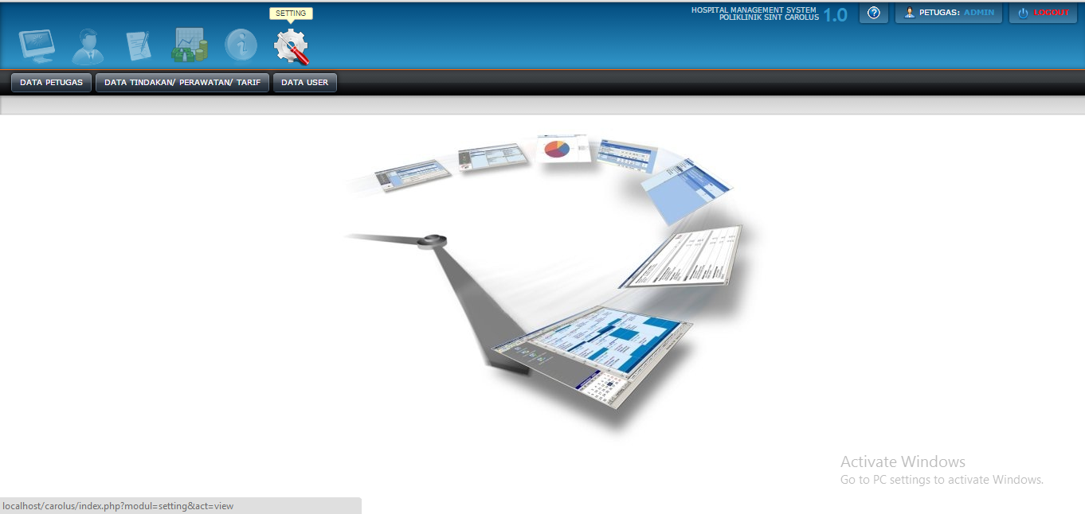

* Petugas / Data Petugas

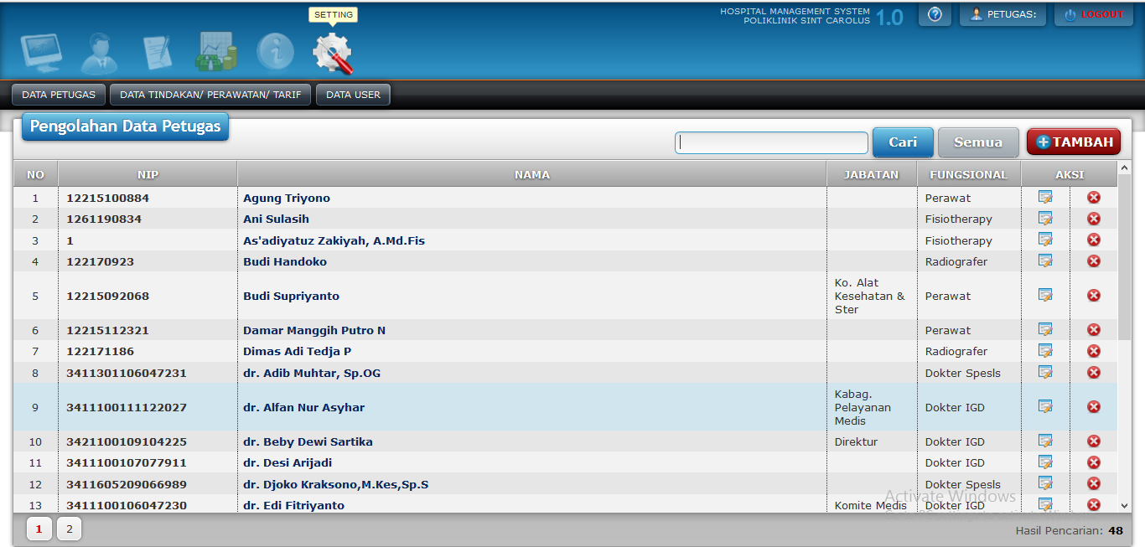

* Data Tindakan / Perawatan/Tarif

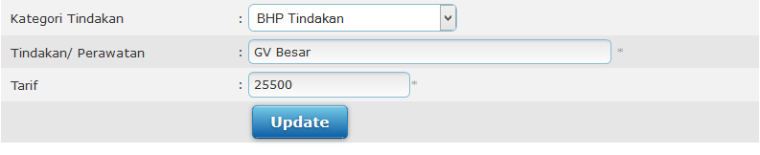

* Hak Tiap User

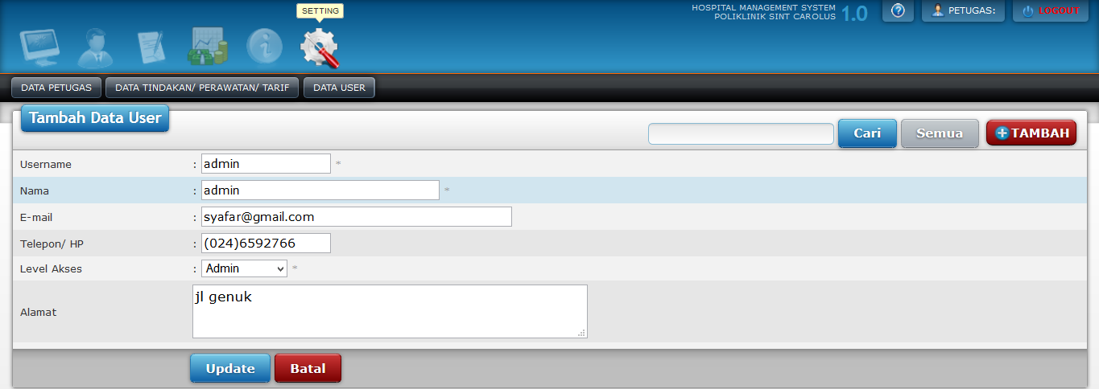

1. Accunting

* Halaman Login

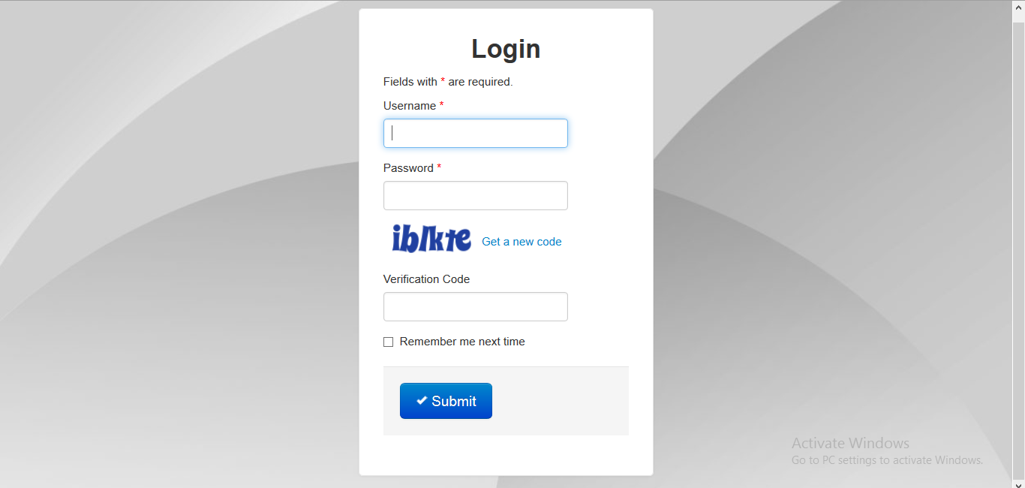

* Home

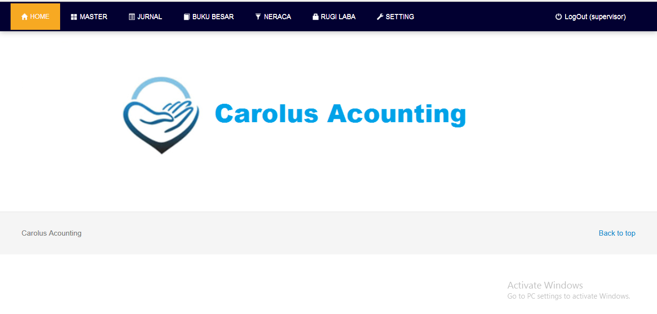

* Master

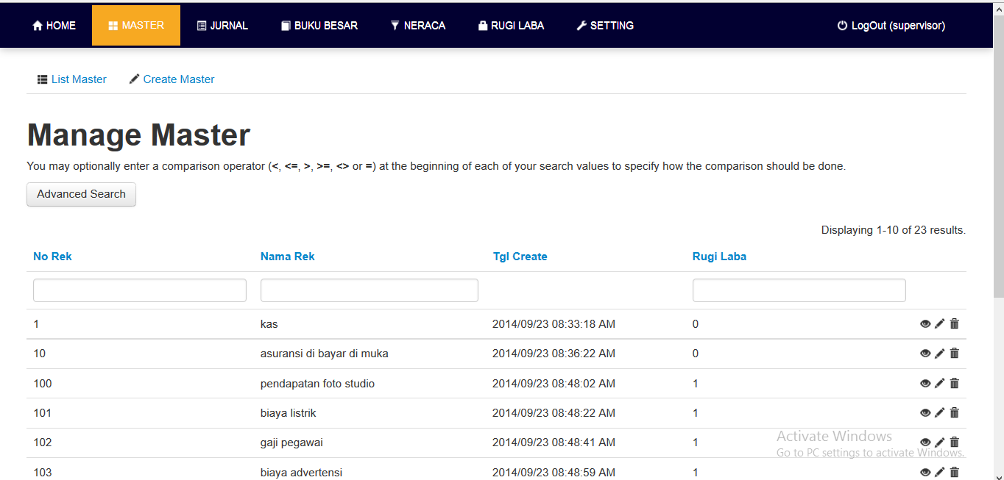

* Create Master

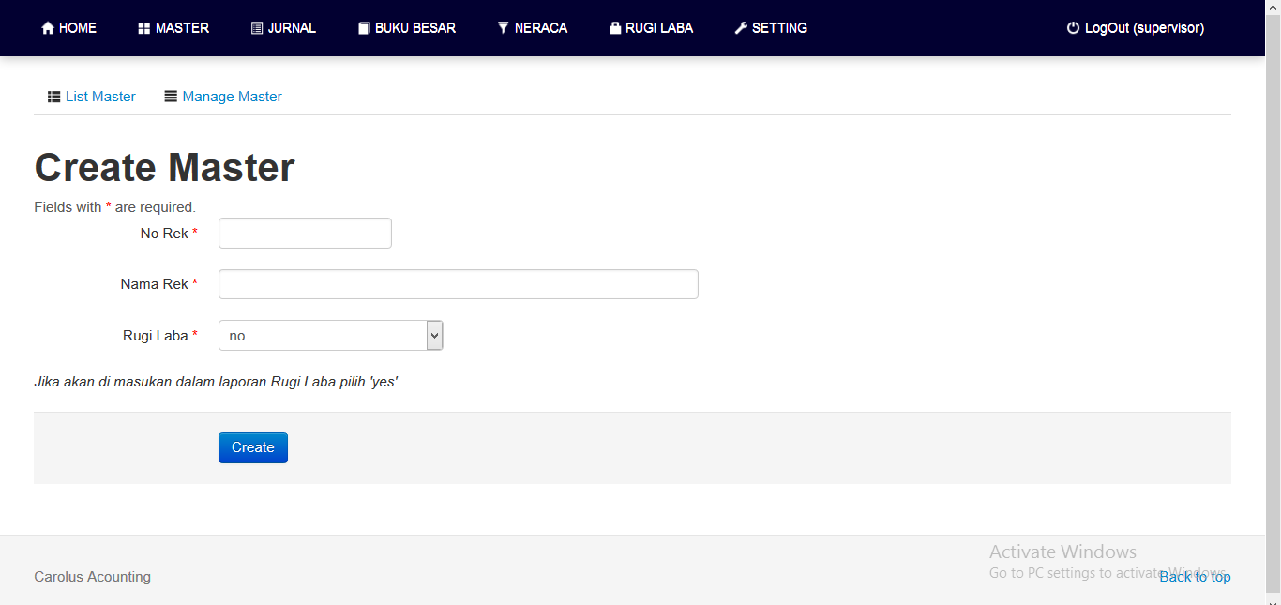

* Jurnal

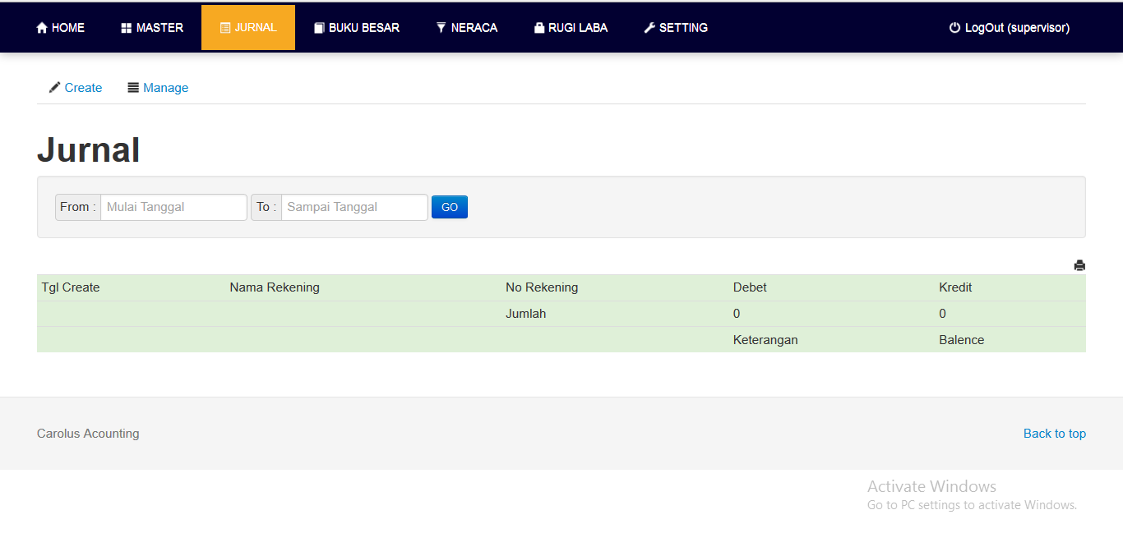

* Create Jurnal

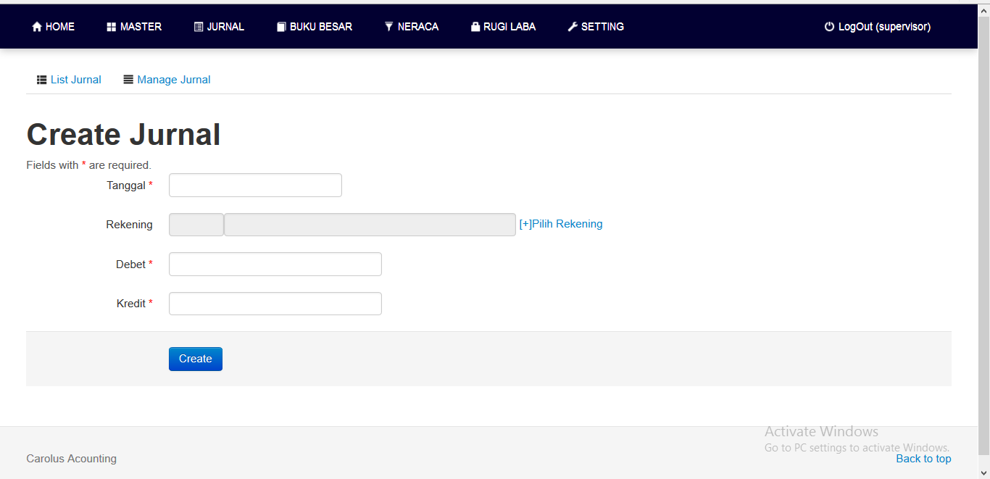

* Buku Besar

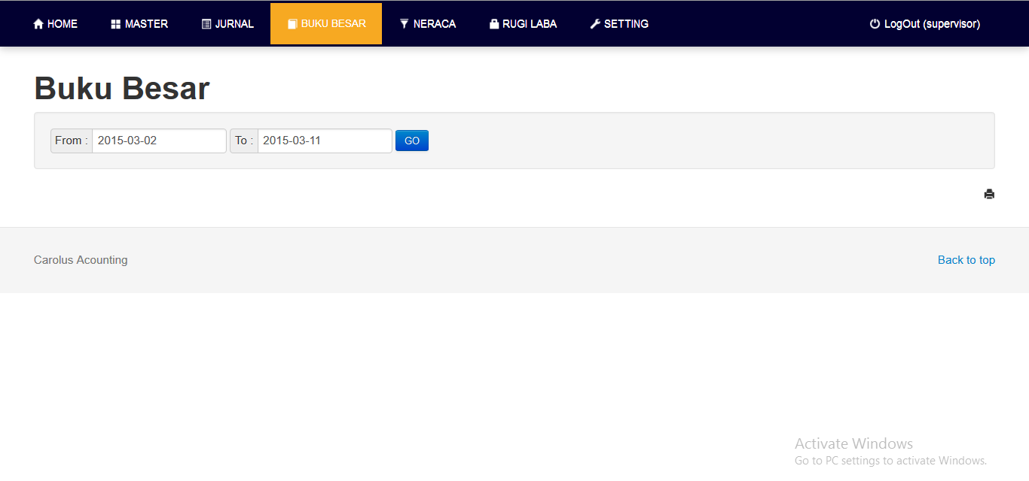

* Neraca

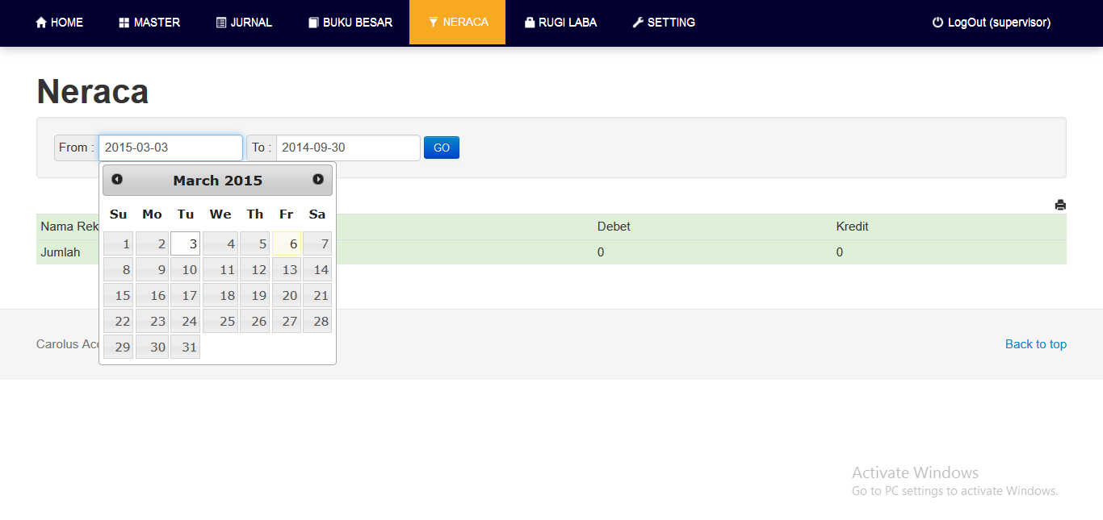

* Rugi Laba

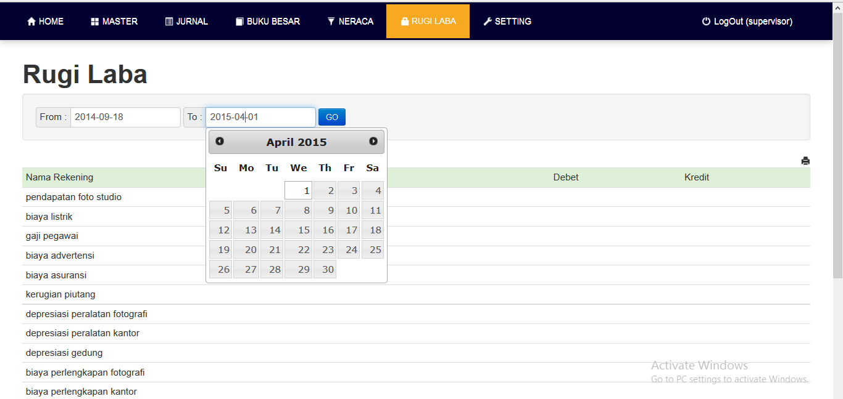

* Setting

